

**Faculty of Computers and Artificial Intelligence**

**Cairo University**

Assignment III – CS251

Intro to Software Engineering

2022-2023

Dr.Mohammad El-Ramly

T. A’s: Ahmed Hassan & Hassan Morad

Submission date: 13 - 5 - 2023

|  |  |
| --- | --- |
| Alan Samir Hakoun | [alanhakoun@gmail.com](mailto:alanhakoun@gmail.com) - 01006891062 |
| Sohaila Abdelazim Khalifa | [sohailakhalifa03@gmail.com](mailto:sohailakhalifa03@gmail.com) |
| Sara Tamer Mohamed Bihery | [sasooelbihery@gmail.com](mailto:sasooelbihery@gmail.com) |

**Project Phase 2: System Design (6)**

**Attached as:** *CS251-2023-S25,25-****AhmedHassan & HassanMorad****-20210755-FinalToffeeS****D****Sv1.0.pdf*



**Project Phase 3: Implementation (4)**

**Attached as:** *TofeeProject.file*

****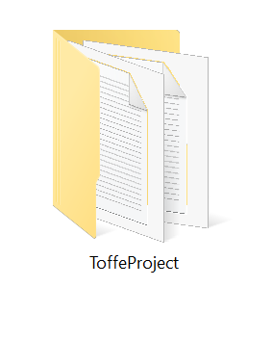

**Project Phase 4 (Bonus): Documentation and Clean Code (1)**

**Attached as: ToffeProject\documenation.file**



**Individual Task: TechRadar (1)**

20210492: Tools : 77

One of the tools mentioned in Technology Radar website was **Obsidian**. It got my attention asespecially in our career as new technologies and ideas come to line to keep yourself dated to these updates you should have a place to keep track of your knowledge. Yet it is used for a wide range of purposes, including personal note-taking, project management, academic research, and knowledge sharing within organizations.

Obsidian is a note taking software that allows connecting of notes to create knowledge graphs and store the notes as plain markdown files in a local directory in a device, allowing the user to keep their data. Therefore, its tools help users organize and link their notes in a flexible, nonlinear way.

Through my research about it and trial to the application software I’ve found several features that makes it different and worth trying such as it treats the notes written as a database, consequently I can search easily through the notes about a data or either filter or sort it. Moreover, while using the application to write a new note I can easily refer to several old notes in other windows vertically or horizontally. Similarly, a well feature obsidian has is the graph view, it presents a knowledge graph of all the notes in the application showing their relation and links between them. It’s a useful feature if you want to explore related themes and notes. Similarly, the command palette, found in the sidebar of the application allows running serval commands on the file and the application.

On the other hand, obsidian is customizable software as it gives the opportunity to the user to custom the theme he likes and fell comfortable in, also adding any plugins and extensions. In spite of taking space of the user device, it has a great aspect of privacy and security as it stores all the notes locally on user’s device, ensuring the privacy of the data entered. Also, it has the feature of live preview mode as some users would like to publish the notes on their blogs or wikis or even share it with their collogues. This mode shows how the formatted note would look like when published.

To sum up, I had a good experience tying obsidian and I would highly recommend to any student or a worker looking for a note taking tool that provides a flexible process of note taking with organizing and visualizing features. Especially the idea of the markdown support and privacy options makes it different from other similar applications.

20210155: Tools : 72

**C:\Users\Lenovo\AppData\Local\Microsoft\Windows\INetCache\Content.MSO\A2791EAE.tmp**

It functions by examining the code being worked on by a developer and producing recommendations for the subsequent lines of code. The suggestions, which can be as simple as statements or as complicated as code structures, are based on patterns detected in the existing code.

Understanding natural language is one of GitHub Copilot's standout characteristics. The tool will produce code that carries out the functionality specified by developers when they provide it with a simple English description of what they want the code to perform. Because of this NLP capacity, developers don't need to have a lot of specialised knowledge to communicate their ideas to the tool.

The capability of GitHub Copilot to gain knowledge from the code that a developer is writing is another advantage. The programme can produce more accurate and pertinent suggestions as it analyses more code. This indicates that when GitHub Copilot gains more knowledge about the particular programming language and project the developer is working on, it will become more and more helpful.

Nonetheless, GitHub Copilot has its limitations much like any AI tool. Although it has the ability to generate code suggestions, a developer is still needed to comprehend and adapt the code to meet their unique requirements. The tool has restrictions on the programming languages it can support as well; at this time, only Python, JavaScript, TypeScript, Ruby, and Go are supported.

Despite these drawbacks, GitHub Copilot has the ability to completely change the way programmers write code. By producing precise code suggestions, it can help developers save time and minimise errors. Additionally, the tool can help novice developers learn and understand programming concepts by generating code examples that demonstrate how to implement specific functionality.

In conclusion, GitHub Copilot is an exciting AI tool that has the potential to change the way that developers write code. It has the capability to improve productivity and reduce errors by generating accurate suggestions for code. While it is not a replacement for human developers, it can greatly assist them in their work and make programming more accessible to novices. As the tool continues to learn and improve, it is likely that we will see even more impressive capabilities in the future.

20210755: Tools: 65



ChatGPT

As a software engineering student, there are several ways in which I found useful using ChatGPT. Here are my review and what I found useful:

Knowledge and Expertise: ChatGPT gives me access to a vast amount of information about software engineering. It can provide me with information on different programming languages, software development methodologies, software design patterns, and much more.

Assistance with Assignments: If I need help with assignments, it can assist me in a variety of ways. For example, it can provide me with ideas and suggestions for my project, help me with coding issues, and even proofread my work.

Career Advice: it can provide me with insights into the latest trends, technologies, and best practices. It can also offer guidance on how to prepare for job interviews, build a portfolio, and stand out in a competitive job market.

Resource Recommendations: There are many online resources available to software engineering students, such as online courses, coding challenges, and open-source projects. So, it can recommend resources that are tailored to my needs and interests.

Personalized Learning: It can adapt to my learning style. Whether me prefer visual aids, hands-on activities, or written explanations, it can provide me with the information in a way that works best for me.

Overall, it can provide me with a wealth of knowledge, assistance, and support that can help me succeed as a software engineering student.

**Screen shot for every GitHub account.**

20210755:

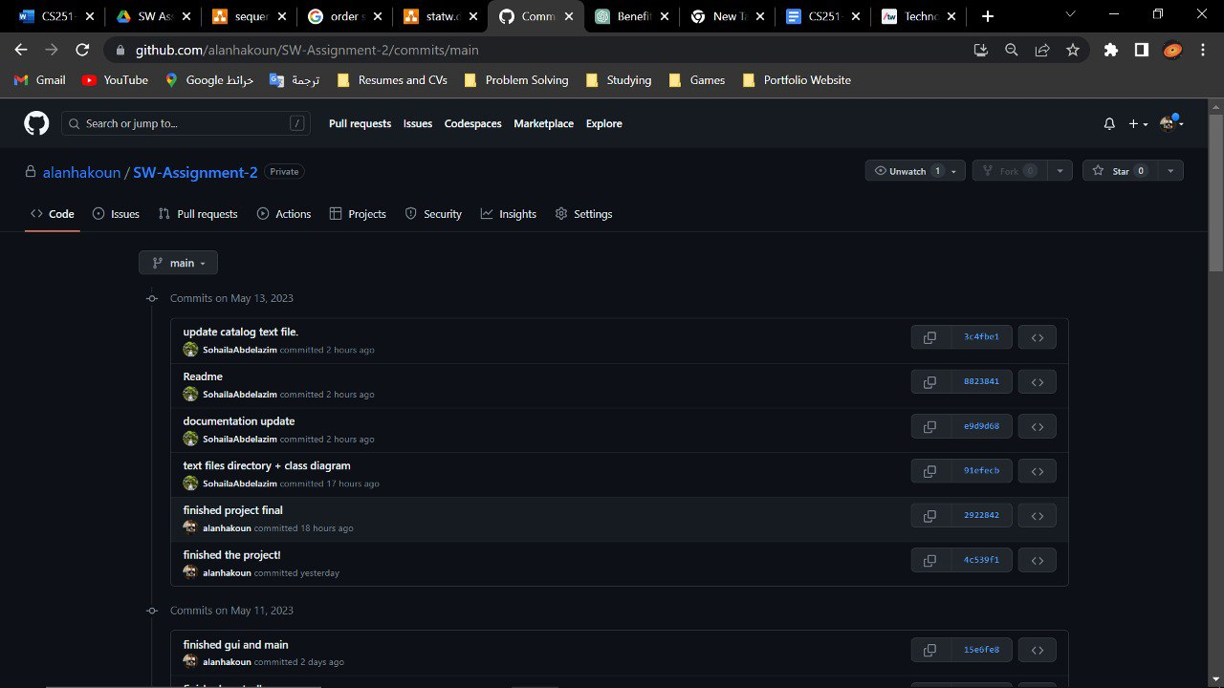

20210492:

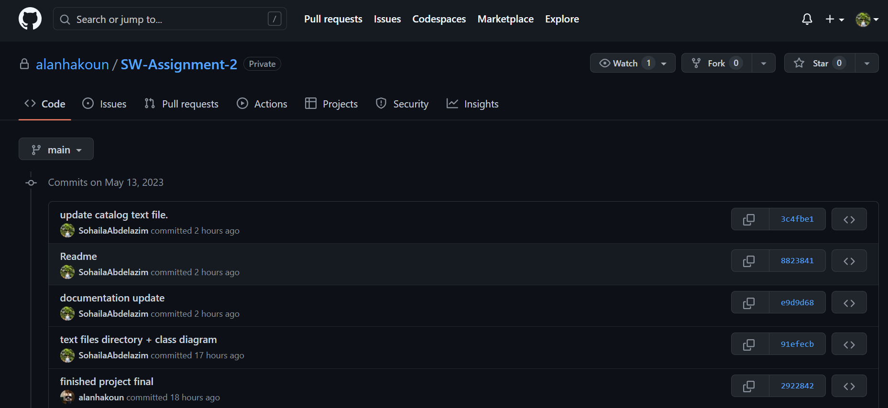

20210155:

